Jeffrey Dean Morgan Reading Ghost Stories In Annandale
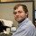 Sam Barron

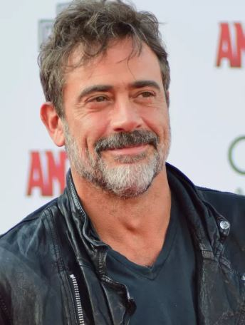
Jeffrey Dean Morgan Photo Credit: File
ANNANDALE-ON-HUDSON, N.Y. -- Negan is once again going to send chills down your spine.
Jeffrey Dean Morgan, star of "The Walking Dead," will be headlining Ghost Stories on Saturday, Nov. 4 at the Fisher Center for the Performing Arts in Annandale at 6 p.m. The performance will benefit Astor Services for Children and Families. Morgan's wife, actress Hilarie Burton, will also be reading ghost stories.
Astor Services is non-profit that provides mental health services, child welfare services, and early childhood development programs.
Before the performance, there will be a silent auction to get an opportunity to read a ghost story with Morgan and Burton.
Morgan owns Samuel's Sweet Shop in Rhinebeck.
For advance tickets, click here or call (845) 758-7900.

